Jim’s Notes on the Tigé (8/11/16)

The Batteries
There are two batteries. There is battery switch in the port stern ballast hold. There are three positions for the battery switch:
- Off (“12 o’clock”) – batteries are off.
- Main battery on (“3 o’clock”) - the main (‘engine’) battery is on.
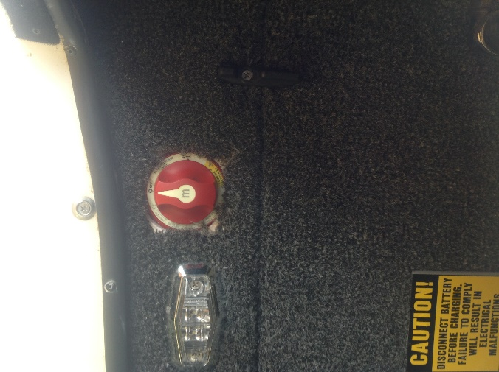
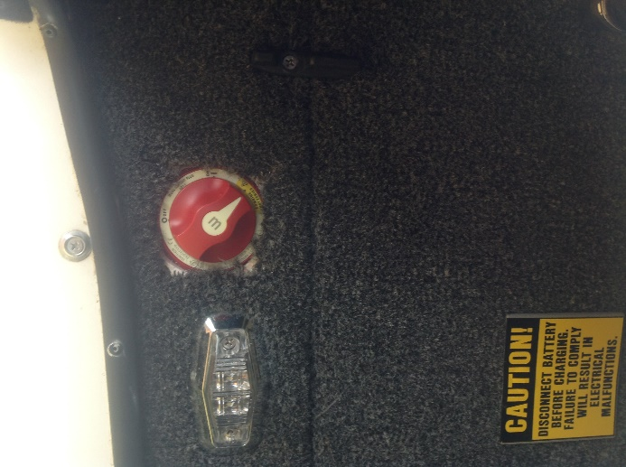
- Both batteries on (“5 o’clock”) – both batteries on (combine batteries).
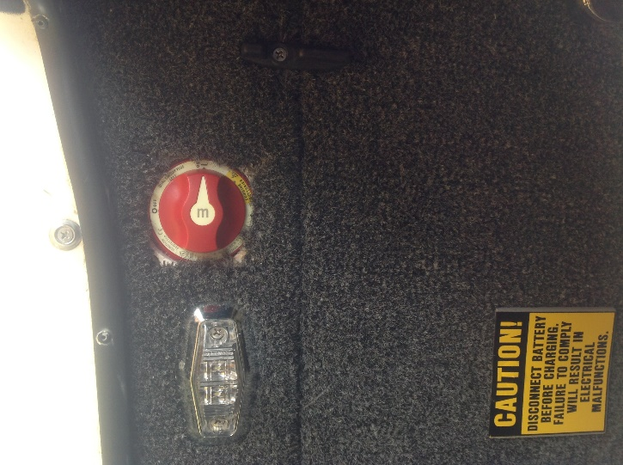
Barry, our salesman who owns the same boat says
- Run the boat with both batteries.
- Turn off the batteries when not in use.

Here’s the explanation: The first main battery is for the engine, primarily. Having a battery to start an engine is a very high priority. If using the main battery only (this can be done, but not recommended), and it begins to go down, you start losing functionality of some of the boat features (ballast pumps, navigation lights, radio, and we experienced this), but there is enough power to start the engine. The primary purpose of the auxiliary battery is a result of the way boats are often used these days: If you go to a bay, drop anchor, attach your foam mat, play your radio, and swim and play in the sun for 4 hours (with the engine OFF), the radio runs off the second, auxiliary battery. The main battery is not drained. In this way, when you decide to end your day on the water and go to start the engine, your first battery is used.

Finally, the reason Barry recommends shutting off the batteries when the boat is not in use is because something might be on. I’ve noticed the blower has been running even after the key was turned off and removed (OK, that’s a pretty good thing for safety, so maybe don’t turn off the batteries in the first 10 seconds, get your life jackets and towels out of the boat first). Also, the ballast pumps are a bit finicky (more below). I’m not convinced, when emptying, that they shut 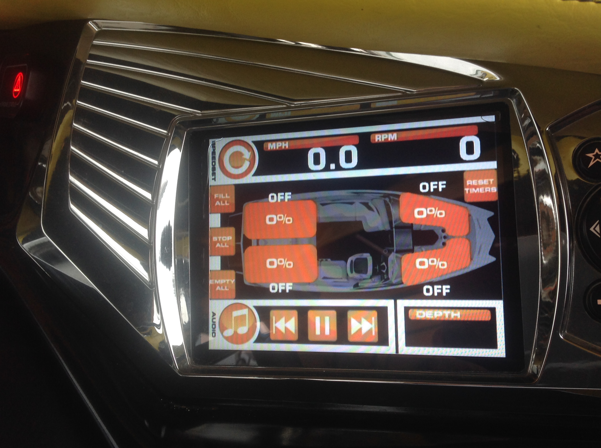off of their own when the ballast is empty. All these things should shut off, but Barry, from experience, says to be safe, shut off the batteries when the boat is not in use.

The Ballasts
These are the bread-and-butter of the boat, because getting the perfect wake is what it’s all about.
- On the ballast screen (shown above) it shows 0%, 25%, 50%, 75%, and 100%. This is a crude estimate for two reasons:
  - Rounding: For example, “75%” only means it is somewhere between 68% and 82%.
  - The percent full given comes from a timer (the computer), it is not an actual measurement. (See resetting timers below).
- Therefore, you may need to adjust.
  - Cole says that if you want 100%, you should fill to overflowing (water spitting out the side).
  - You may need to add or subtract depending on various factors (including people in the boat and the ‘crude estimate’).
- Barry says that he does use the black Velcro to put up the ballast bag when they are not in use. The ballast empties more completely and it helps the well (compartment) dry out.
- Resetting Timers: (See the ballast touch screen.) Since the touch screen percentages are just crude (computer) estimates of the percent in each ballast, over time they could become woefully inaccurate. To reset the timers, empty all the ballasts (and pull up the Velcro wall to get ‘em really empty). Then press Reset Timers on the touch screen.
[The two rear ballasts hold 600 pounds each. The two front ballasts hold 400 pounds each.]

Speed Control and Presets on a different page.

Boat Lift notes will be put on a different page.

Call Barry at Mau Marine if you have questions. He is very helpful, he likes to be helpful, is very knowledgeable on the Tigé, and wants happy customers.

